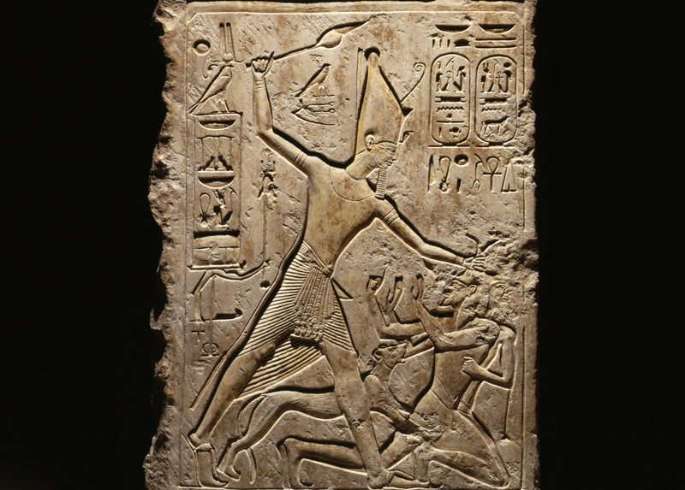 |  | Who Am I?
Classical World, MExico & Central America, Egypt |  | 50 minutes

In this lesson, intermediate-level students will use the countless statues, busts, and figurines in the Museum collections to practice describing people in their target language. They will become comfortable talking not only about physical attributes, but also social roles, such as king, servant, and soldier. They will practice using adverbs and adjectives (including comparative and superlative forms) to contrast different artifacts.

Vocabulary List

- Descriptors: young, old, male, female, wealthy, powerful, poor, short, tall, thin, big/bigger, small/smaller, heavy, round, hairy, bald, elegant, plain, pretty, ugly, reclining, sitting, standing, realistic, artistic
- Moods: happy, sad, cheerful, gloomy, friendly, rude, funny, angry
- Body parts: head, hair, eye, ear, mouth, teeth, neck, shoulder, arm, hand, finger, chest, stomach, leg, knee, feet, toe
- Social Roles: ruler, pharaoh, king, god, goddess, priest, servant, slave, soldier, official, farmer, character

Grammar
- Superlative and comparative
- Adverbs

The Museum Visit

Language Bingo (15 minutes)
Distribute the Language Bingo sheets and ask students to find an example for each square (discourage them from using the same object more than once). Every time they find one, they should write down the name of the piece in the space provided.
Group Discussion (25 minutes)
When most or all of the students have Bingo!, gather the group together and ask who found a particular character on the sheet. The volunteer then leads the class to the object they selected to go with that character. Then, ask each student to use a different word or phrase to describe that object. For example, we may know that this person is dressed elegantly, but can we guess what his profession is? Once simple descriptors have been exhausted, move to another object.
Possible questions include:
- Do you think this person looks happy? Why or why not?
- Does this person remind you of anyone (friends, celebrities, fictional characters)? How?
- Are any body parts missing from this piece? Which ones?
- (If looking at a stele or narrative image) Who do you think is the main character in this image?
- Do you think this image is a realistic depiction of the real person? Why or why not?

Wrap-up (5 minutes)
Conclude the visit with final questions and comments.

recommended objects

Classical World

Mortuary Statue (B8904)

Marble Tomb Loculus Cover (MS4017)

Head of a Male God (39-42-1)

Grave Stele (MS5470)

Female Statuette (MS5681)

Funeral Stele (MS4023)

Alabaster Cinerary Urn (MS2458)

Sarcophagus (MS3488)

Post-Visit Activities

Party Games
Pretend that time-travel has transported the class to a party going on in the time and place of one of the Museum’s galleries. Each student will pretend to be one of the ‘people’ they saw at the Museum and interact with the other students as they think their character might have acted. How would a king speak to his servants? How would a god speak to a king?

Writing Assignment
Have each student choose an object from the galleries you visited and respond to the following prompt: If you were the person portrayed in this object, would you like this piece or complain about it? Think of how we react to bad photos! Write a short letter to the artisan either thanking him/her for his flattering portrayal or accusing him/her of making you look bad. Use plenty of adjectives to describe the image and how you think you actually look. This is a great way to practice comparative forms (as in, I’m much thinner than the statue!).

Questions?
Ready to schedule a visit?
Contact Penn Museum’s Academic Engagement Department at
classuse@pennmuseum.org

recommended objects

Mexico & Central America

Seated Figure (29-41-726)

Ball Player Figurine (62-30-019)

Standing Figure (61-1-2)

Seated Female (66-30-21)

Egypt (3rd floor- Mummies)

Mummy Mask (53-20-1A)

Statue of Pharaoh (E635)

Statue of an Official (E975)

